**CSCI 588 Specifications and Design of User Interface Software**

**Class Project Final Report**

**University of Southern California**

**Project Title:** A Travel Experience Sharing Website

**Assigned Team Number:**  25

**Team members:**

Name Yuyang Zhang Last 4 digits of Student ID 1525

Name Peijin Sun Last 4 digits of Student ID 0035

Name Yao Fan Last 4 digits of Student ID 8665

**Project status change:**

1.Is there anything changed from your original proposal and /or analysis report?

No

2.If answer “Yes”, clearly state what has been changed.

3.Have you finished all the tasks that you targeted in your original proposal and/or progress report?

No

4.If answer “No”, clearly state what has been changed.

Implementation. We didn’t implement back-end

**Project objectives**

The project aims to build a website about travel experiences sharing, in which users can share their travel experiences by writing articles and uploading photos. In the website, users are able to look through the places that they are interested in, and they can also read the articles and see some photos from other users. Users will also be able to share their own photos and experiences to others and communicate with each other. When designing the website, we will follow the rules, suggestions and guidelines that we learnt in class and make good use of the powerful features of HTML5 and popular javascript libraries to produce nice UI pages and cool effects.

We found out that there are some websites in China about traveling experiences sharing like [www.mafengwo.cn](http://www.mafengwo.cn) (refer to the picture below). Their UI design is not of bad quality, but there are still some problems about it. The old-fashioned style and messy tabs are not corresponding to the beautiful scenery and pleasant traveling experience, and there are some needless links and widgets which will hardly be clicked by users. So we want to revise these problems to build an easy-to-use, beautiful and attractive website.

**Problem statement**

To develop a website described above, there are some problems that we are confronted, including fundamental problems of building websites and that some additional functions we want to implement. Here are the main problems of the website of [www.mafengwo.cn](http://www.mafengwo.cn) below:

* Building the mainframe of the website, including database design, backend functions design, UI pages and relationships between them.
* Designing of effects or animations for showing data and pages.
* The method of gathering source data.
* Additional algorithms like recommending places, articles or photos according to user information.
* Responsive layout.

**System analysis, design, and development**

Overall, in this system, UI designs are apparently improved compared with the former website. As for the UI design of our website, we obey the 8 Golden Rules, and in functions, we developed basic functions that are necessary for a travel experience sharing website, and we also added some pages to help users plan their own travel, and recommended some blogs of other users. In details, we added contact forms, which may be useful when users need technique support, and we also made an error page in case there is something wrong with the server.

This is a half-implemented project. We designed the UI and implemented it using web technologies while we didn’t implement some part of Social Network System because it is so huge for three of us. We didn’t implemented the backend of the website because it’s far from this course which mainly discuss UI design.

We focused on choosing what kind of UI design we needed before we started to build the front-end JavaScript program and CSS design. This should be a typical website, and it has index page, photo gallery, article list, article, destination, contact, registration, and particular destination page in its main framework.

About the 8 Golden Rules, we did some analysis on our project and try to make our website more uniform and easy to be used. After finishing it, we also revised some details of the system to make it obey the 8 Golden Rules.

Consistency:

All the headers and footers in every page are identical. We tried to use the same style to present text and buttons.

**Universal usability:**

We tested all the links of the website to make sure that they work properly and direct users to the correct page. We put the important content or major part of the page on where users can see them easily.

**Informative feedback:**

We designed several feedback popup and dialogs, which can be used for giving users feedback such as wrong input warning, email format warning, password unmatched with user name.

**Dialogs to yield closure:**

Users can easily click on back button to go backward to the previous page whenever they want.

**Prevent errors:**

We designed choosing box to let users choose the date.

**Easy reversal of actions:**

In this website, users are not required to input or take action much. So if they felt they'd done something wrong, they could click on backward button of the browser to go back to the previous page.

**Internal focus of control:**

Users can also sign up and sign in by inputting less information if they don’t want to fill in complicated personal info in the profile page. Also, they can get response from the user interface without waiting too much. The interface can rapidly responds to users, and users are in charge of the interface.

**Reducing short-term memory load:**

Users do not need to remember much information. If they forgot what they've done or forgot what they’ve looked before, they could easily use search feature to look for what they want, which is on the top of the page.

Index.html is used as a default page as an entrance of the website. Users can start their journey here, and they can see brief instructions of how to use this website.

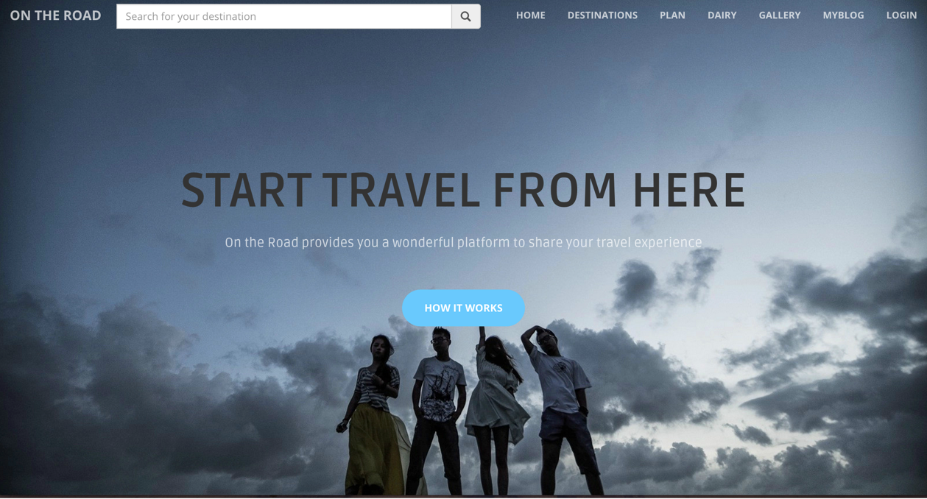

*Index.html part 1*

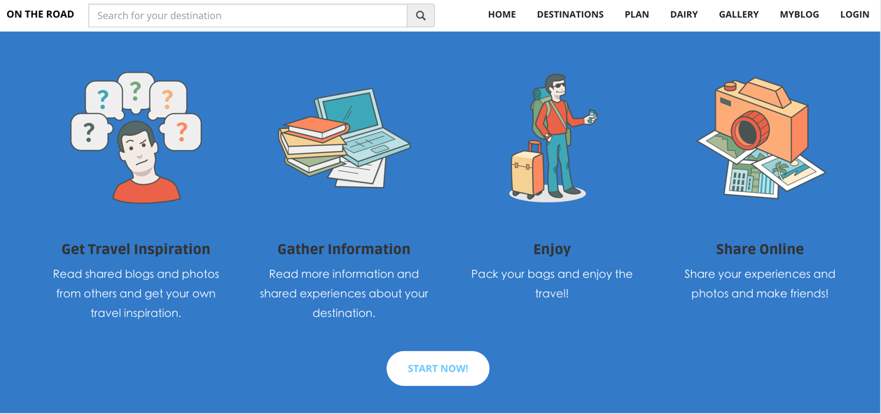

*Index.html part 2*

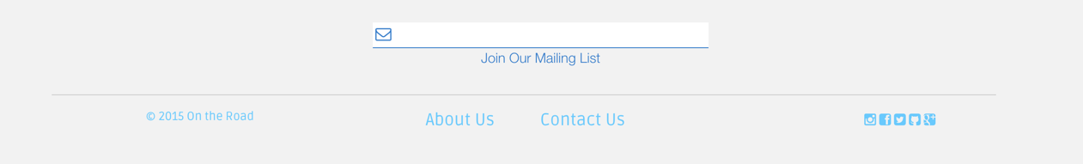

*Footer*

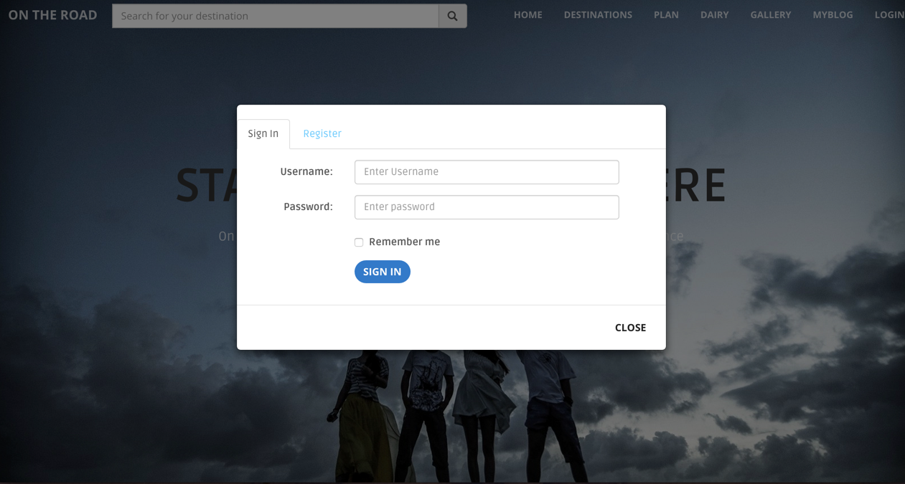

*Login Page*

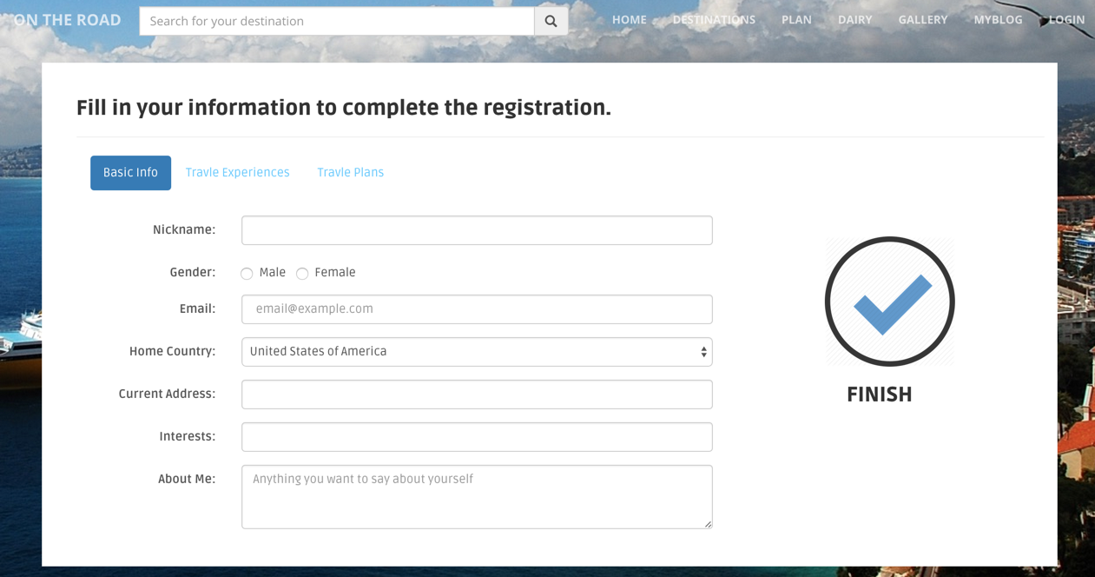

*Register Page*

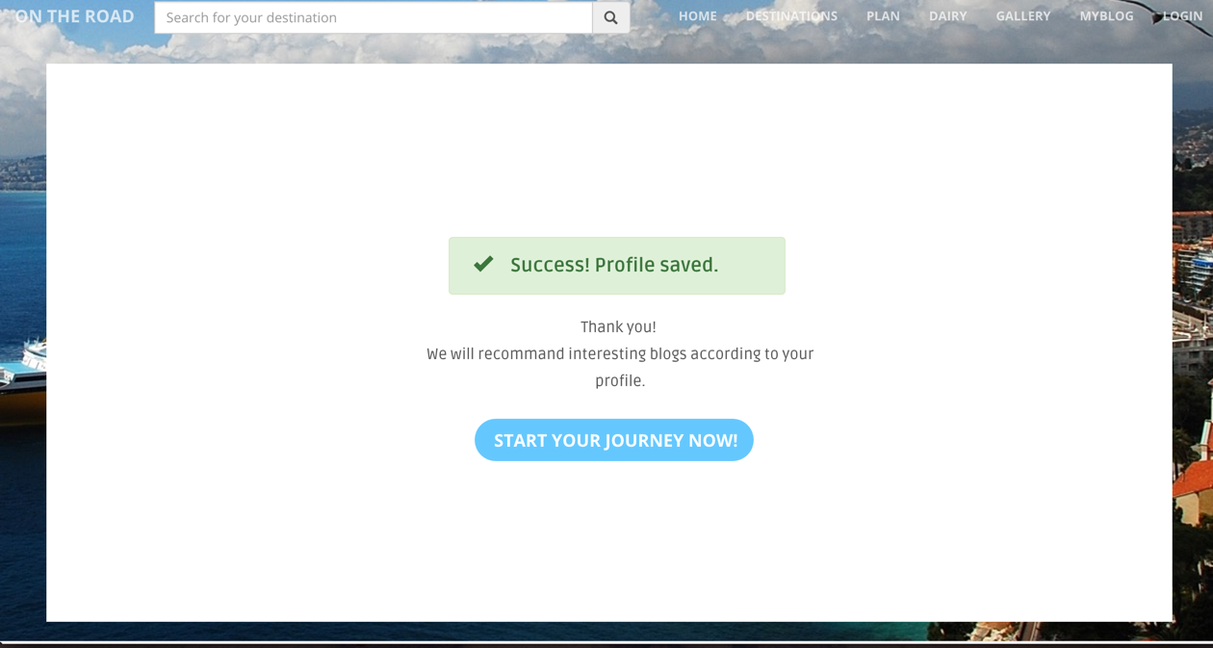

*Registration Succeeded page*

This is the page of destinations. Users can search for their potential travel destination on the page or anywhere else in the navigation search box.

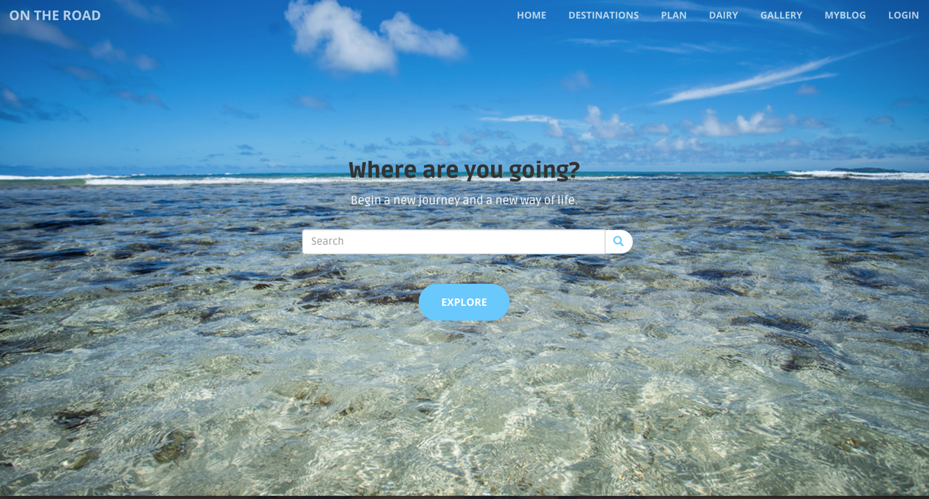

*Destination.html part1*

At the bottom of the page, users can see different popular destinations that other users on the website are looking for or have been traveled there before.

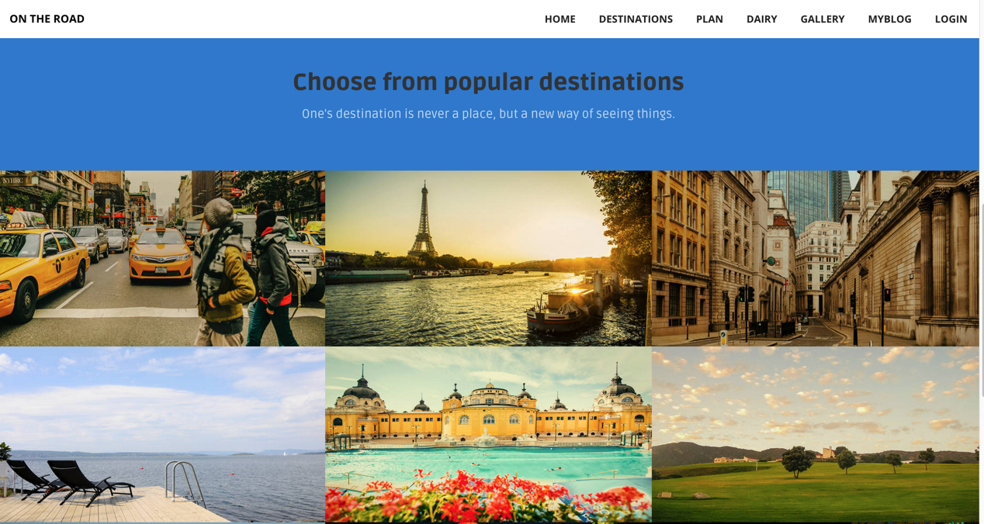

*Destination.html part1*

Next is a list of traveler diaries. Users may be interested in different places and they can find the introduction of the same place they want to travel to. Other users may share different points of interest and talk about how they feel about the place.

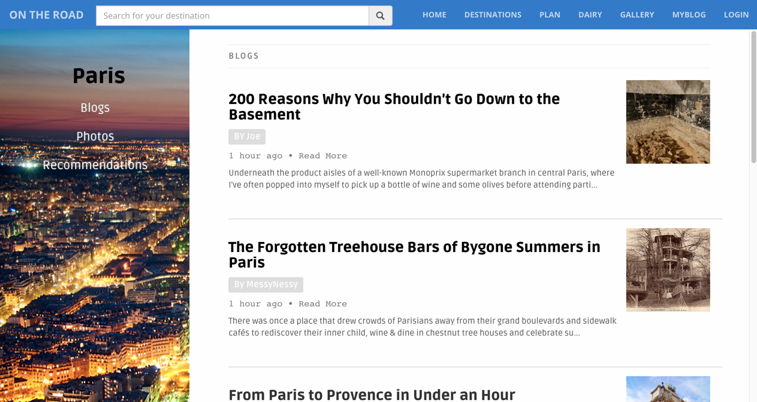

*Dairy lists*

By clicking on the different links of the list, users can go to different page, and read the content of the diary, which contains text and pictures.

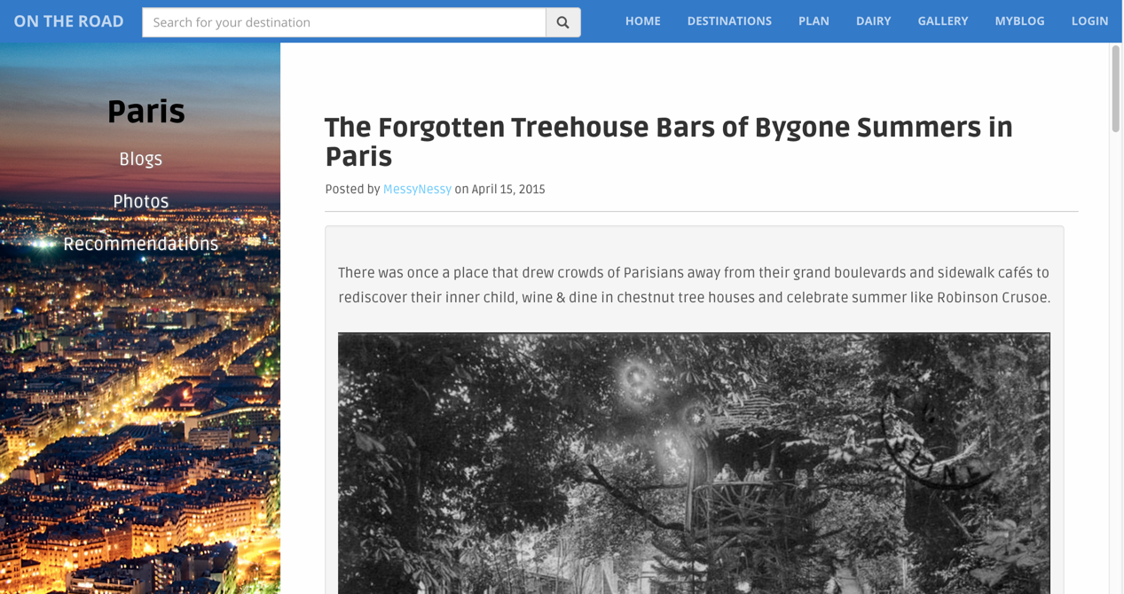

*Dairy contents*

Users may find it interesting when they extremely want to travel to a certain destination, so they might want to learn about the place. As a result, we designed this page to introduce a certain place. Here, we use the example of Paris.

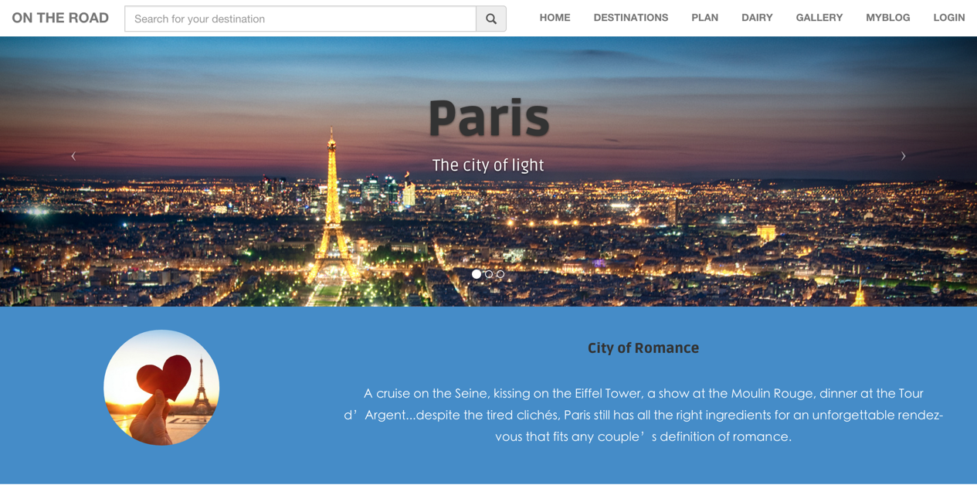

*City Details part 1*

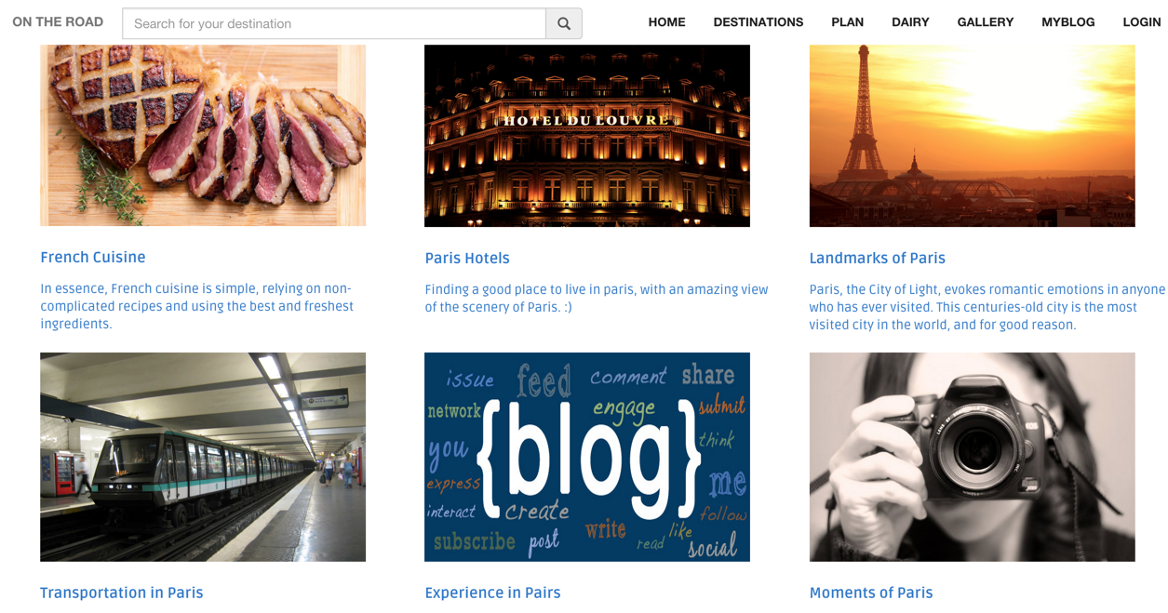

*City Details part 2*

When there are a lot of introductions of point of interest, users may don’t have enough time to read one by one. So we have designed a gallery page for those who just want to browse different photos.

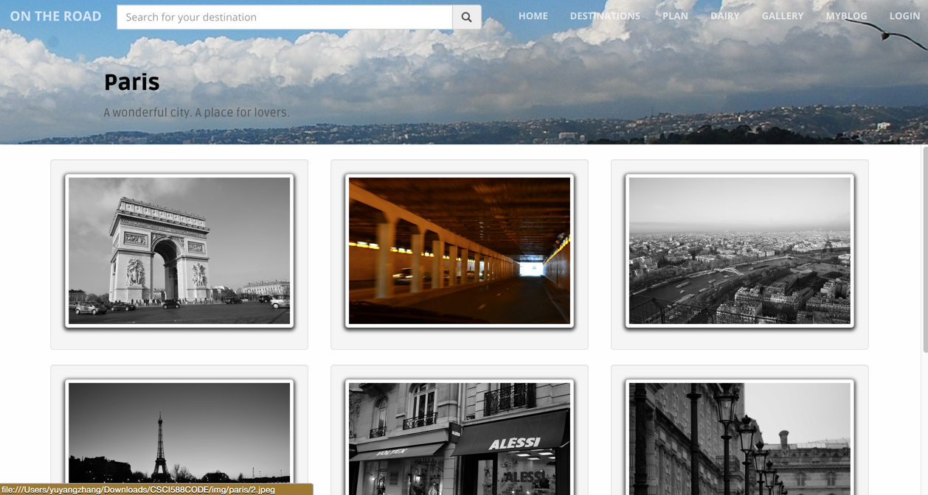

*Gallery*

By clicking on those thumbnails, users can open a larger view of the photo. They can also go to the previous and the following page by clicking left and right buttons on either side. At the bottom, there are several tiny thumbnails to show where the user is, which will not make user frustrated. The design is like this:

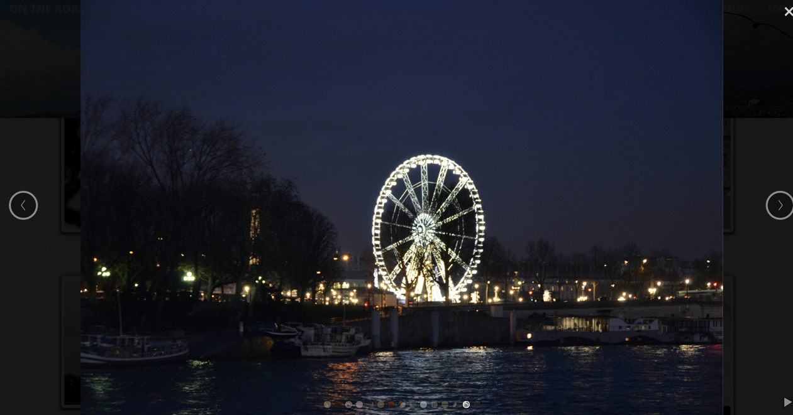

*Photo Details*

On almost every website where users need to access to his or her own individual resource, designers need a login and signup page to let users login by inputting Username and password. We also have this feature, which is like a popup view.

To let the website know what type of traveler the user is or what places may interest the user, we designed a registration page where users can type in personal interest, some travel experiences before and even travel plans.

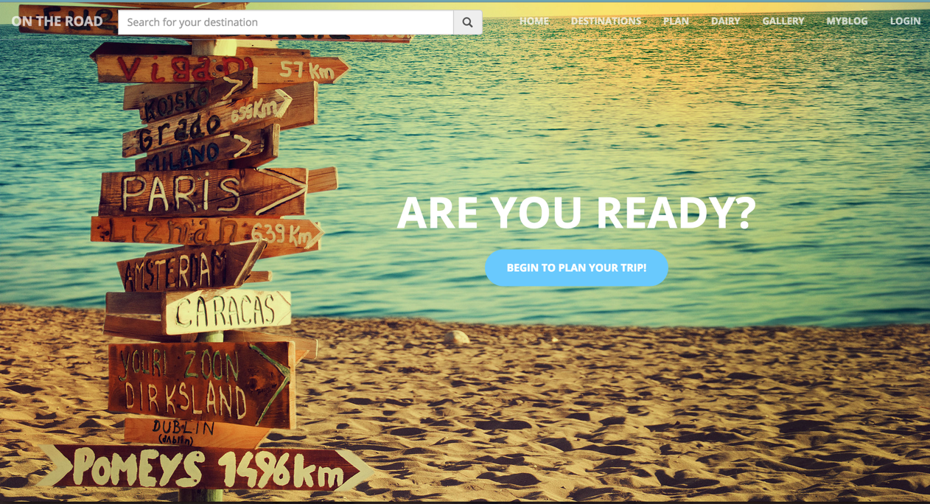

*Travel Plan part 1*

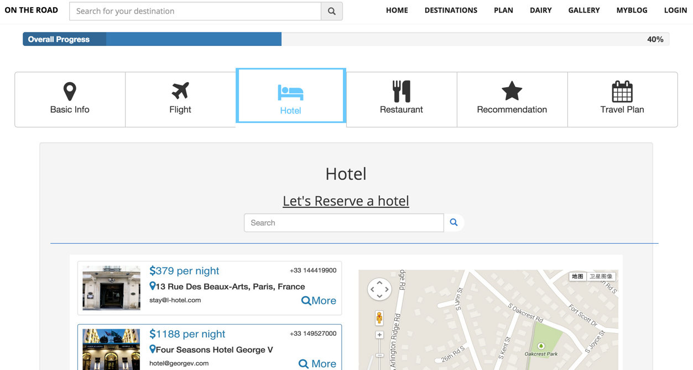

*Travel Plan part 2*

Some users may have found some interesting places which they want to share with friends, so we designed this page to let users look through their personal diary.

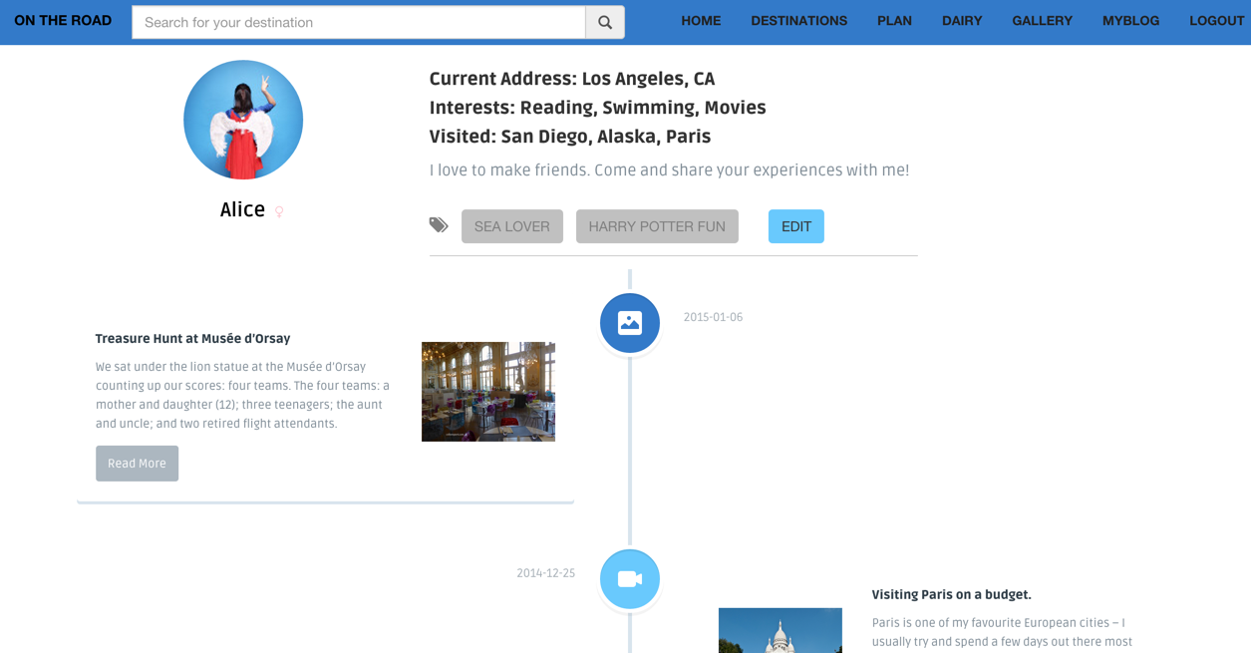

*Personal Page*

Users may find some error links on the website or mistakenly open a wrong link, but we prepared a specific page for the situation. This page shows clearly that the user have found an error and can easily revert to the home page or to report the error to technical support.

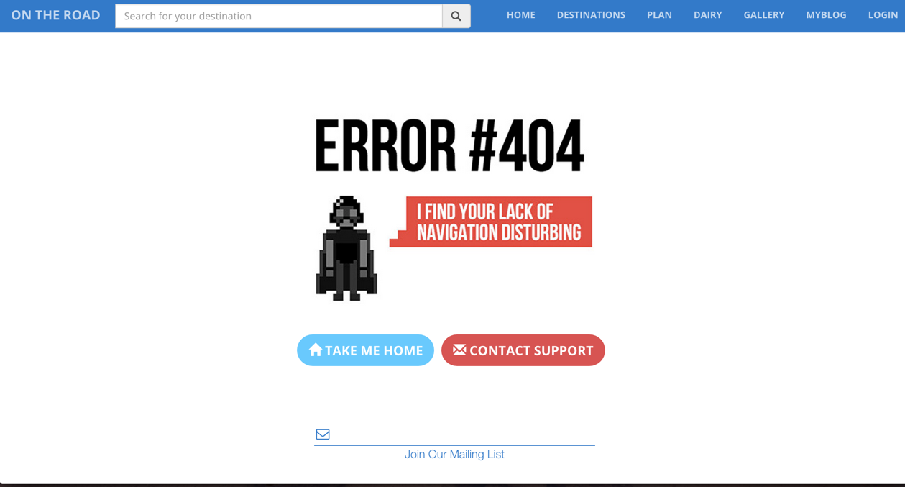

*Error Page*

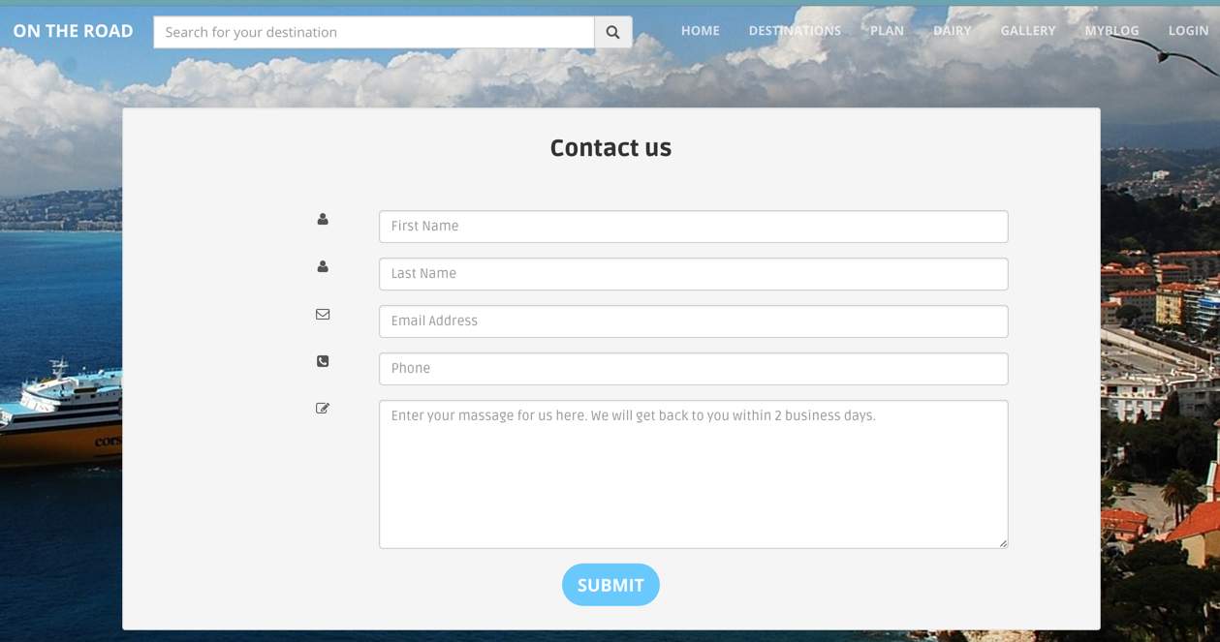

*Contact Form*

**System functionality**

To view the website, all that users need is a modern browser.

The system can help users with their decisions on their travel plan, in functionalities, firstly, the system provides plenty of information about popular destinations or places of interest that users may be interested in. Users are able to get information about these places, including transportation information, food information and more. Then users are able to read articles and view pictures that posted by other users, so that users are able to know more details about their destination. What’s more, this is also a very good platform for different users to make friends with each other, and talk about their experiences during their trip. After that, users are ready to go on their trip, and enjoy their travel, and finally, they can also return to our website to share their photos and stories and enjoy the happiness of sharing.

Besides the main function of the website, we also provide some basic functions that are useful for all the websites.

This website has pages as main page, photo gallery, article list, article, destination, contact, registration, and particular travel destination pages.

The system requirement is that users need a modern browser which supports HTML5 and CSS3, and that they need to enable JavaScript of the browser they use.

Users can directly open any of the pages listed above. Then they can use links to open the page to read diary or to see the picture that they are looking for.

They can look for a destination and search for relevant information of it before they travel to the place.

The mobile version of this website has not been tested and assured very well, so users may feel somehow confusing to use a smartphone or a small-screen device to browse the website.

**Results and user evaluation**

Finally, we produced a website which presents a travel experience sharing website. In this website, users are able to get information about cities they want to go. Users are also able to share their travel experiences and photos on this website.

Overall, the user interface is designed for users to reduce their stress, to save their time on searching for certain features of the website, and most importantly, to share travel experience in the system as quickly as possible.

Users just need to click on different links in header, body of the page, and the footer. From the index.html file, users can go to all the pages of the website.

We tested all the links. Most of them are linked to the certain page correctly. Users can easily go to home page, destination, travel plan, diary, gallery, timeline page. They can also search for the destination that they like in the navigation bar. They can take advantage of the features above on every page in this website.



Some of them need further back-end implementation to make the feature complete. If users need to register, they can click on the register button and input relevant information, and after they click on submit button, back-end implementation will deal with the data that the user generates in the future.

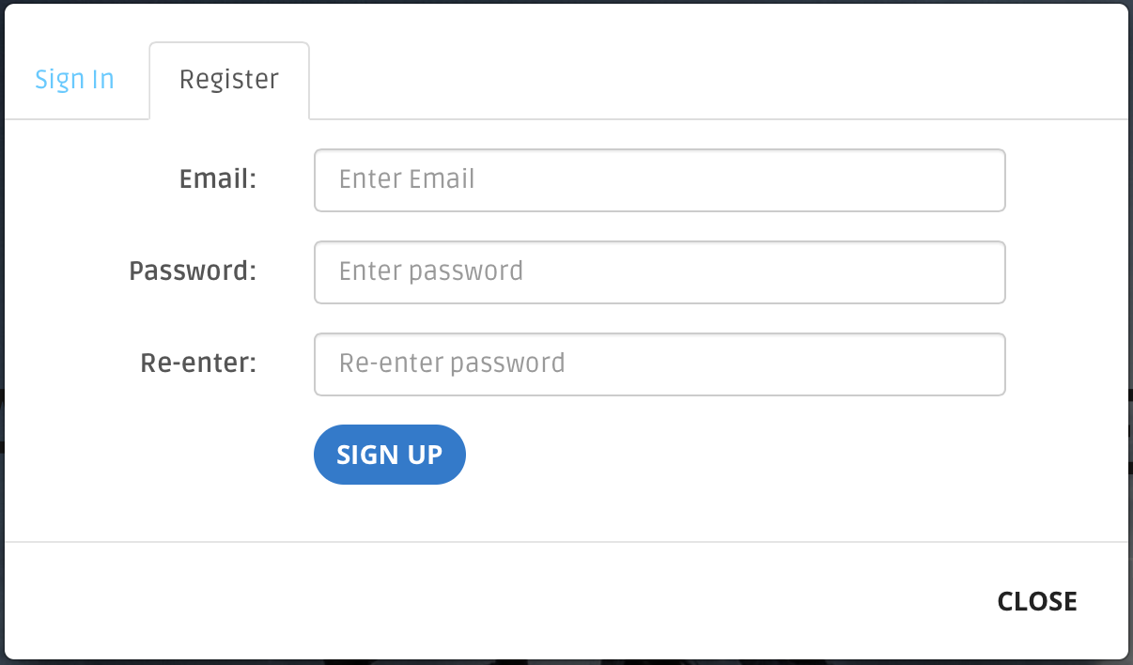

When users want to travel to a certain place, they can make a travel plan using this feature on the following page. Filling in basic information of the travel team will be very helpful.

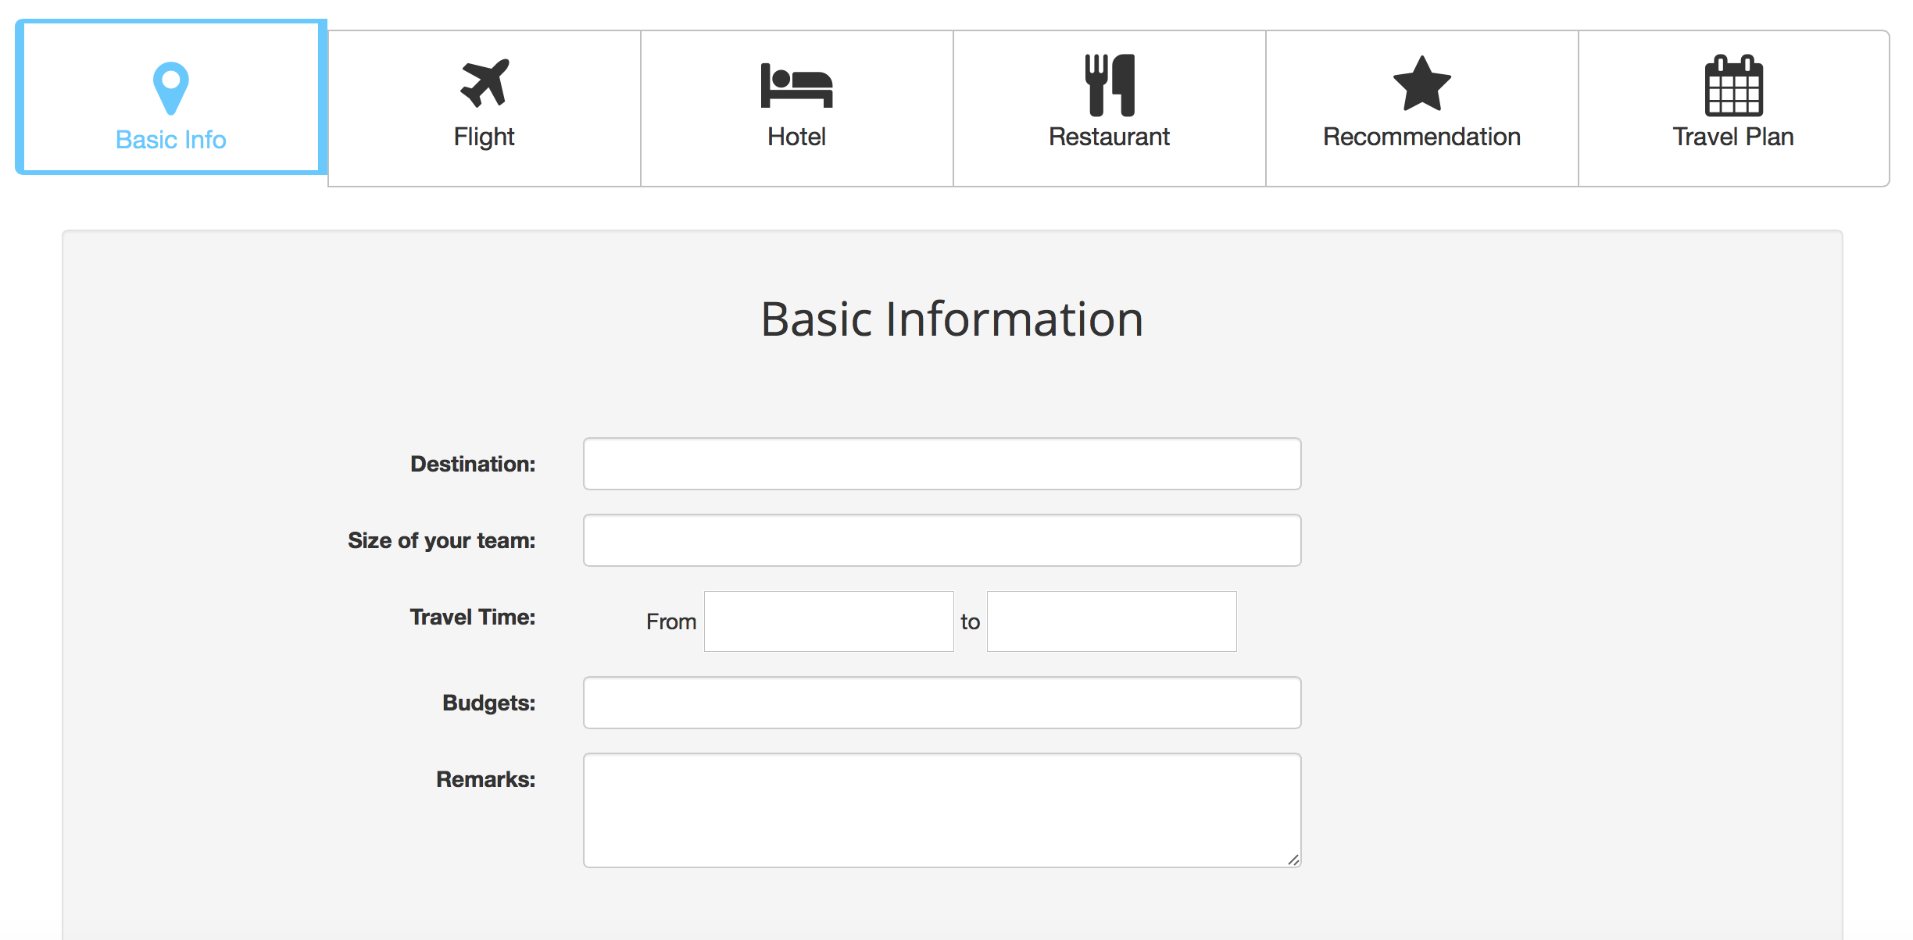

Users can also search for flight info under the second tab of the page. Users can type in arriving date and departure date to book a flight conveniently, and they can choose if they want a one-way or round trip.

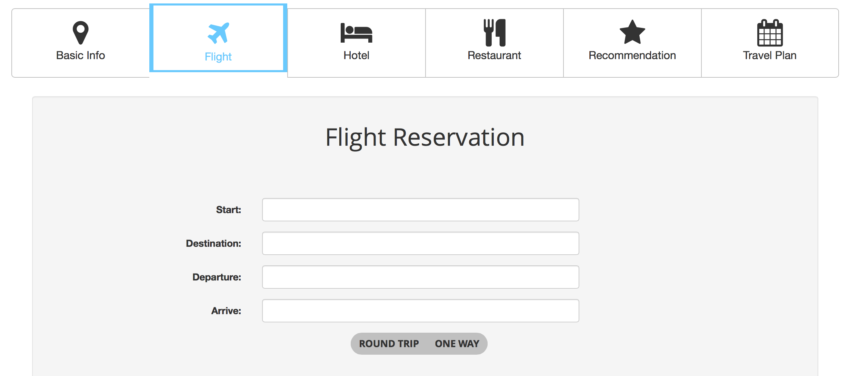

Booking a hotel is right after flight reservation. Users will choose a hotel from several choices. At the same time, they can know how much it takes and where it is in the city.

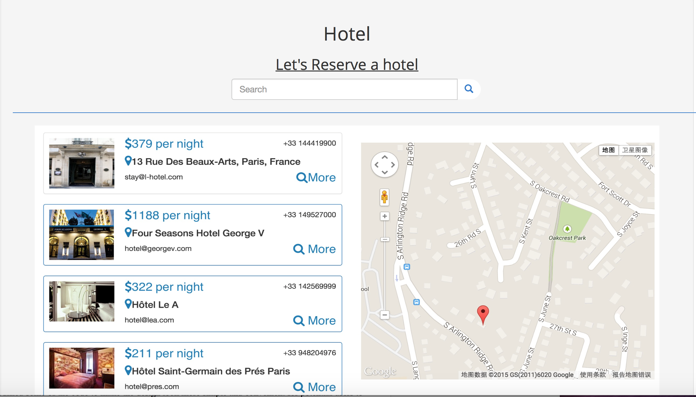

There are also several options of nice restaurants for travelers.

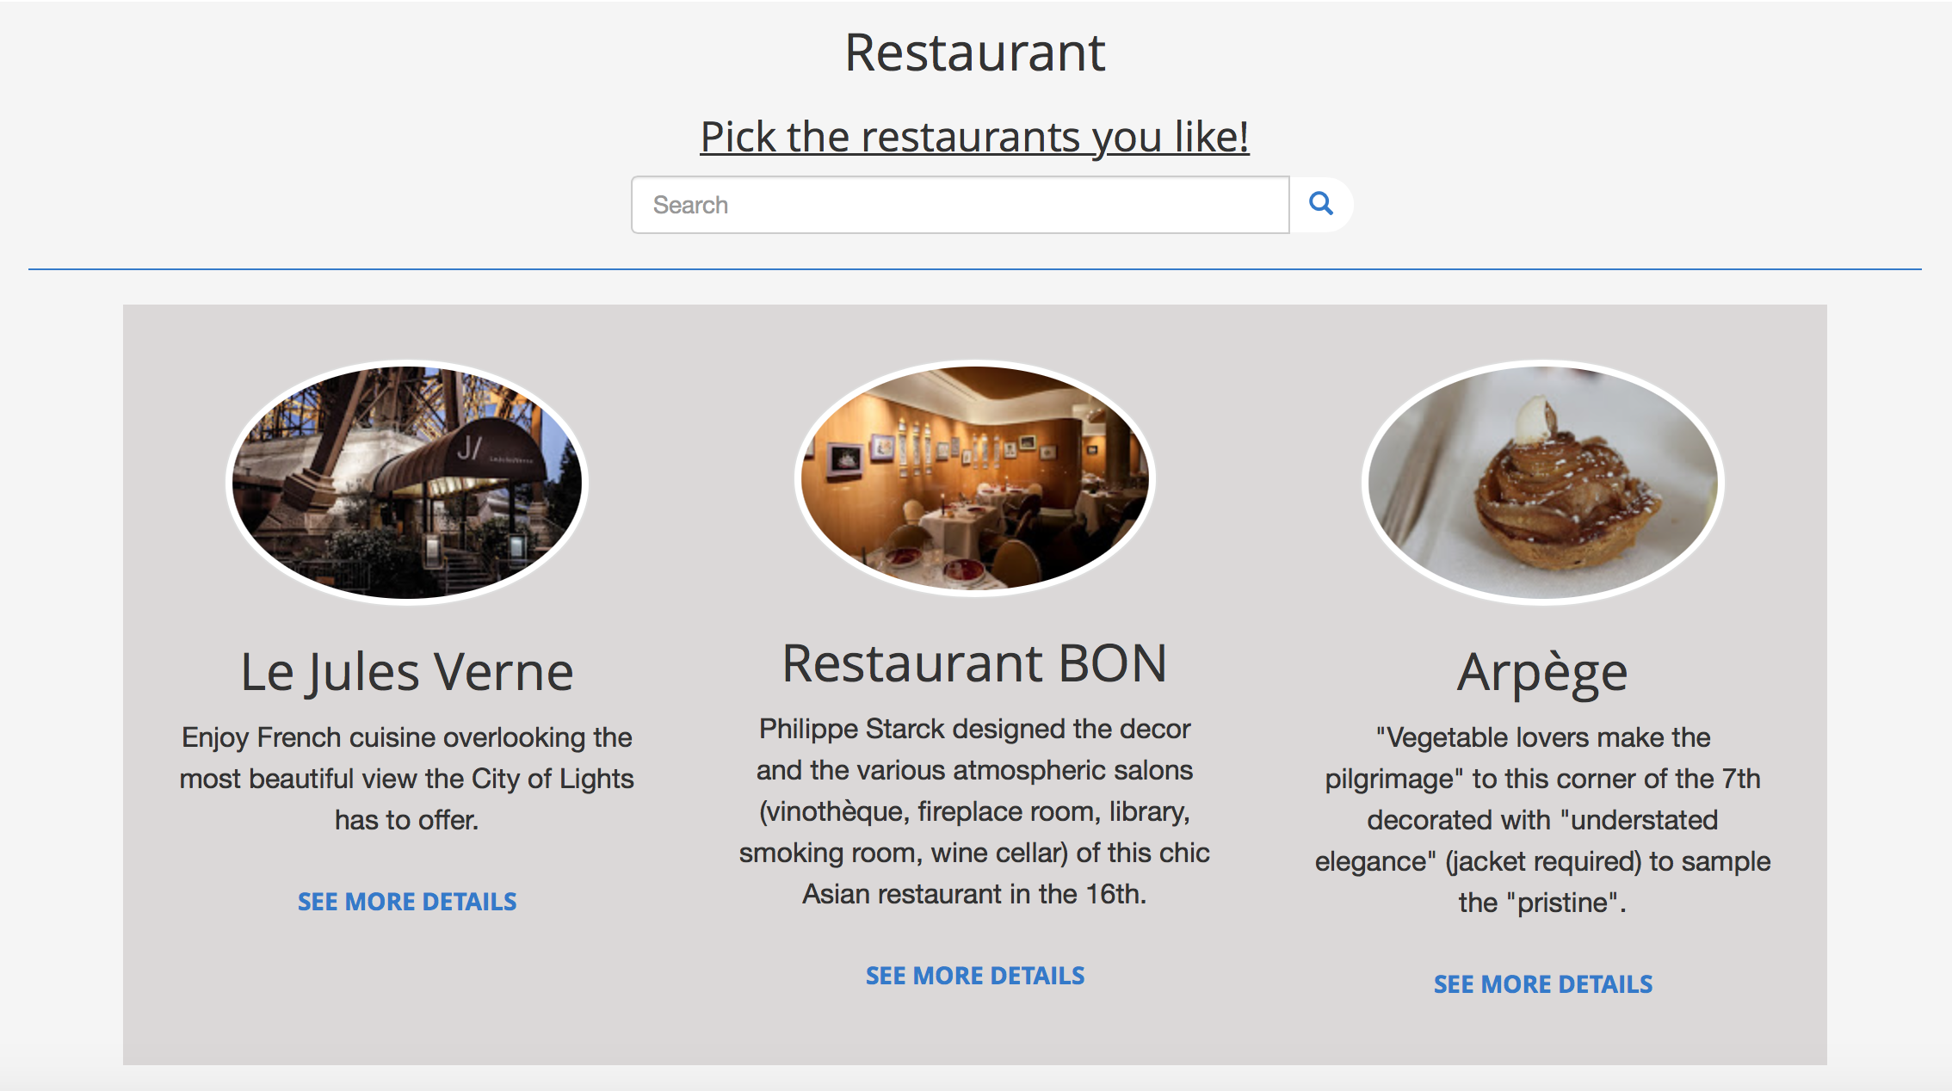

Different person may have different ideas on their minds. They may have different angles to look at a place. So user may need other people’s recommendation before they go to a certain point of interest.

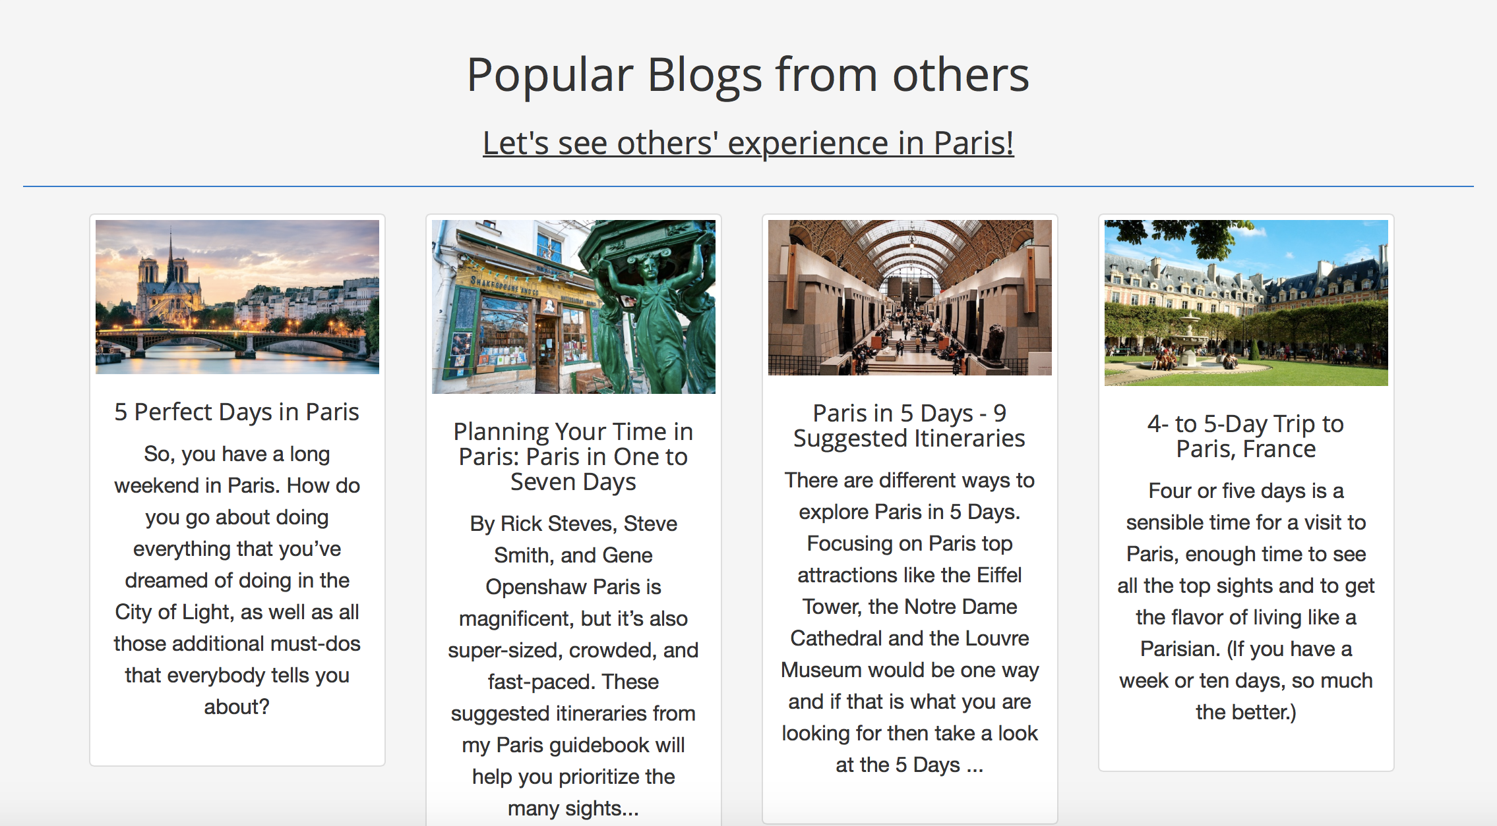

Finally, users can make a schedule for the travel.

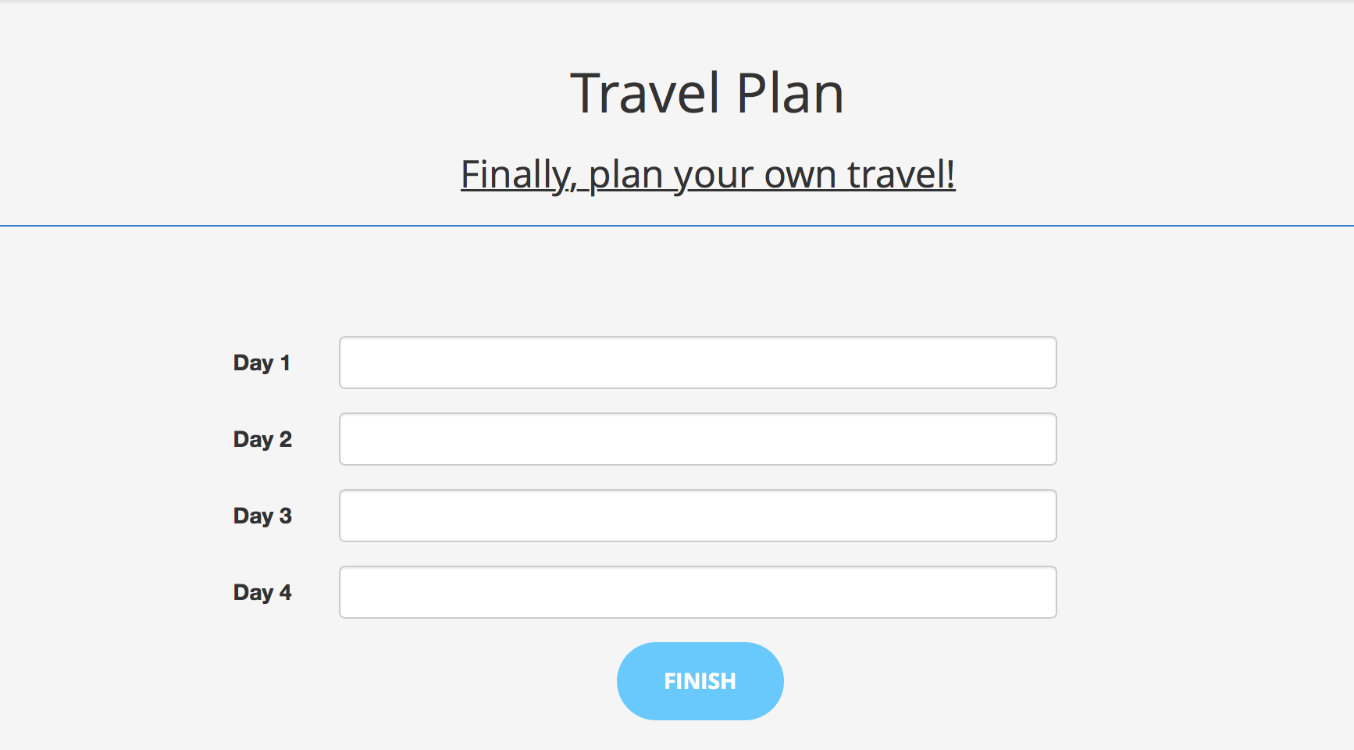

Other users may think your travel experience is so attracting that they want to learn more about where you have been and what ideas you have about several places. They can take a brief look at your timeline page to check if your previous travel experiences interest them.

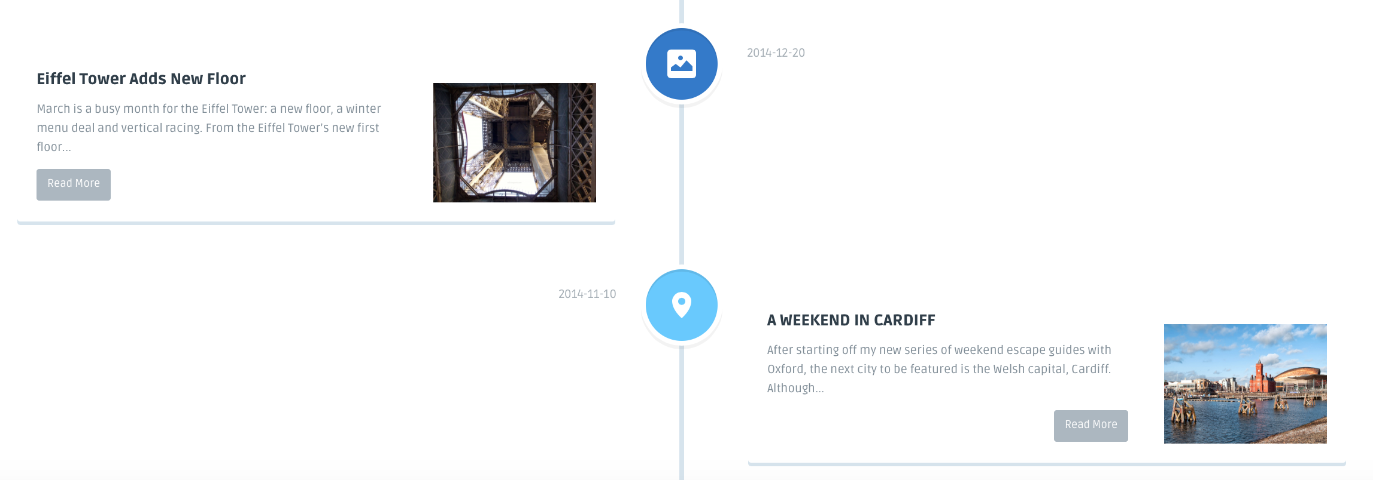

**Conclusion**

This is a project focused on front-end. It improves the original design of the Chinese travel experience sharing website of [mafengwo.cn](http://mafengwo.cn). We used Bootstrap as the front-end template to make it easier for us to develop, and modified some of the code to make the design look more simple and convenient for potential users to use. We used the knowledge from another computer science course Web Technologies, so we did not need to spend too much time on learning relevant techniques that we might need in the process of development.

We want to further implement the project to make it more complete not only on front-end, but also on back-end. On the frontend side, we will try to finish the whole Social Network System to make the whole system more complete and easy to be used. These parts include dairy and photo posting page, which is very important for the system. As for the UI design, we may also revise some part of the website to make the effect more attractive. On the backend side, we may add more back-end programs to make it work properly so that it can serve different types of users. We want to make it a real usable travel sharing website. We may also sell this website design to [mafengwo.cn](http://mafengwo.cn) to check what a valuable product that we have built.

**Comments/issues/complaints/suggestions (optional)**

This project looks simple but it really took time to re-arrange the style of the user interface from open source template to what we want in order to strive for one of the goals — consistency. We focused more on the UI design of every page in the website to make it obey 8 Golden Rules, while didn’t manage finishing the whole building of the system.

What’s more, different browsers render the same HTML code in slightly different ways, which requires us to spend a lot of time on debugging those parts.

Some of the CSS code conflicted with other part of the code in some files. We needed to figure out why that happened, and fixed the problems.

The 8 Golden Rules is so important that every designer should follow to design their user interface no matter that is for a mobile application, or web application, or any application which needs users to use it.